**t2=0:0.5:20;**

**a = input (“enter a”)**

**k = input (“enter k”)**

**x2=k * exp (a * t2);**

**subplot (2, 2, 1)**

**plot (t2,x2);**

**xlabel('Time');**

**ylabel('Amplitude');**

**title ("k * exp (a * t)");**

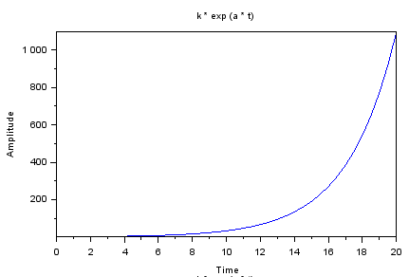

**subplot (2, 2, 2)**

**plot2d3 (t2,x2);**

**xlabel('Time');**

**ylabel('Amplitude');**

**title ("k * exp (a * t)");**

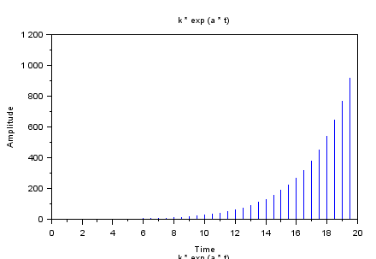

**a = input (“enter a”)**

**k = input (“enter k”)**

**x2=k * exp (a * t2);**

**subplot (2, 2, 3)**

**plot (t2,x2);**

**xlabel('Time');**

**ylabel('Amplitude');**

**title ("k * exp (a * t)");**

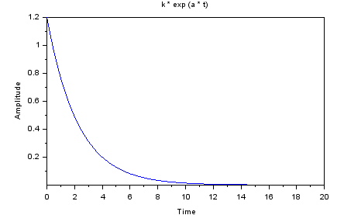

**subplot (2, 2, 4)**

**plot2d3 (t2,x2);**

**xlabel('Time');**

**ylabel('Amplitude');**

**title ("k * exp (a * t)");**

